## GIT – module 2

### Case study merge-conflict



Solution:

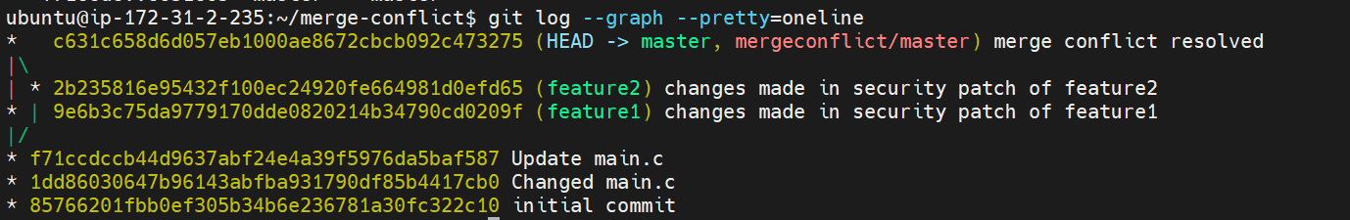

<https://github.com/saaritssinha/merge-conflict>

### Case study git-workflow



Solution:

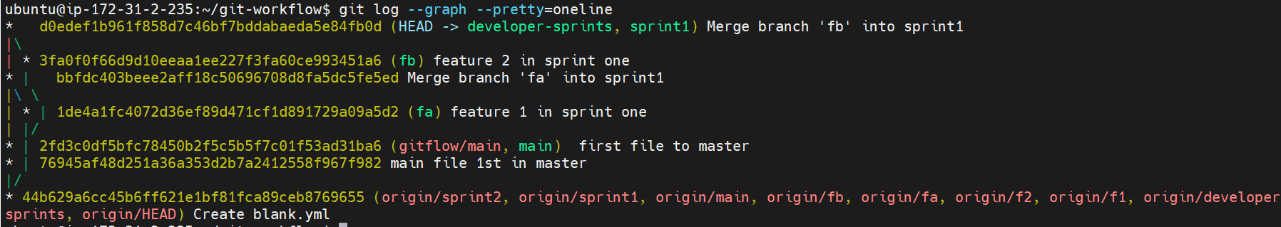

<https://github.com/saaritssinha/git-workflow>

### Module git assignment 1



Solution:

<https://github.com/saaritssinha/assignment>